Name And Title  Lucio Miele, MD, PhD.  Title: Cancer Crusaders Professor of Genetics and Medicine/Oncology  Director, LSU-LCMC Cancer Center  Louisiana State University Health Sciences Center  And Louisiana Children’s Medical Center Health System  Mailing Address and Contact Information  Louisiana Cancer Research Center  1700 Tulane Avenue, Rm 914  Street 533 Bolivar Street, CSRB 657  City, State, Zip New Orleans, Louisiana 70112  Office: +504-210-2837  lmiele@lsuhsc.edu | Current Photo  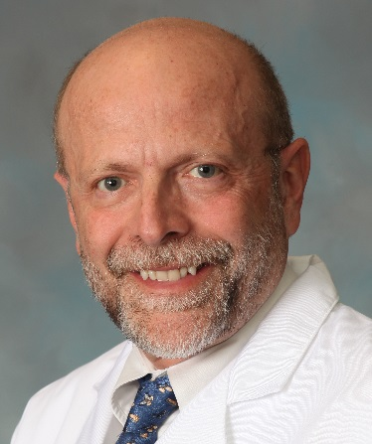
Dr. Miele is the Cancer Crusaders Professor of Genetics and Director, Louisiana State University – Louisiana Children’s Medical Center Health Cancer Center. He also serves in the following capacities: Louisiana Clinical and Translational Sciences Center: Director of Biomedical Informatics; and University of Alabama Center for Clinical and Translational Science Partner Network: Associate-Director and K12 Program MPI. Dr. Miele completed his medical training in Naples, Italy, his PhD dissertation at the Max-Planck Institute for Molecular Genetics in Berlin, and his fellowship at the Human Genetics Branch of the Eunice Kennedy Shriver National Institute of Child Health and Human Development (NICHD, NIH). There, he used innovative informatics approaches to predict the active site of secretoglobins, which resulted in a Nature publication and a US patent. Upon joining the Center for Biologics Evaluation and Research (CBER), FDA, he began his work on Notch genes in cancer and the immune system. At CBER, Dr. Miele was a member of the Divisions of Monoclonal Antibodies and Clinical Trials Design and Analysis. Upon returning to academia, he served as co-chair of the NCI Cancer Therapy Evaluation Program task force on clinical trials targeting cancer stem cells. A large part of Dr. Miele’s research is devoted to biomarker discovery and precision oncology, using integrative bioinformatics and human biospecimens. He has made major contributions to our understanding of the role of Notch signaling in cancer biology and immunology. At LSUHSC, Dr. Miele has created the Precision Medicine Program, becoming the site PI for the Southern “All of Us” program, as well as receiving an NIH National Cancer Institute P20 grant in partnership with Moffitt Comprehensive Cancer Center to perform breast cancer research and a SPORE P20 to investigate the immunogenomic diversity of human triple-negative breast cancers. He is a member of the American Association for Cancer Research (AACR) Breast Cancer standing review panel, institutional PI for the AACR GENIE Consortium, and co-Chair of the Community Engagement Committee of the Nutrition for Precision Health Study. He is also the LSUHSC PI for the National Patient-Centered Clinical Research Network New Orleans site (REACHNet). Dr. Miele has authored 286 peer-reviewed publications to date, with a SCOPUS H-factor of 83 and a ResearchGate H-factor of 89. He routinely chairs or participates in NIH, NCI, NCATS, DOD and international review panels. He has mentored 52 mentees to date at all levels from undergraduate to junior faculty. As KL2 co-director, and from 2024, K12 MPI for the CCTS, Dr. Miele mentors K-funded scholars involved in translational projects. Dr. Miele also serves on the National Advisory Committee of the Robert A. Winn Awards for Excellence in Clinical Research.

Signature:

Lucio Miele, MD, PhD.

