MUSC Lancaster Medical Center
800 W. Meeting Street
Lancaster, SC 29720
Site Coordinator
Casey Cato
ccato@comporium.net

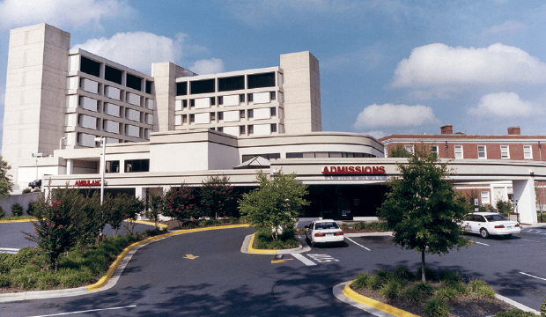
Director of Medical Student Education
Lee Thomas, MD

Hospital Information
MUSC Lancaster Medical Center is your community healthcare provider; a 225-bed, all-private room facility. We believe in the power of people to create great care. We’re more than 120 physicians and healthcare professionals strong. We are a place where technology and skilled professionals come together to provide compassionate, customer-focused care. And we work hard every day to be a place of healing, caring and connection for patients and families in the community we call home.

In the Cardiopulmonary Services department we offer a wide range of outpatient services that include:
Pulmonary Function Studies, Echocardiograms, Exercise Stress Testing, Holter Monitoring Electrocardiograms, Therapeutic and Diagnostic Bronchoscopies, CT guided Lung Biopsies
Transesophageal, Echocardiograms, Routine and Sleep Deprived Electroencephalograms

Some of the imaging services we offer include:
Digital Screening / Diagnostic Mammography, Stereotactic Breast Biopsy, High Resolution 64 slice CT Scans, CT Angiography, Coronary Angiography, MRI, Nuclear Medicine Studies, Ultrasound Studies, Bone Densitometry, Digital Radiography, Interventional Studies, Lithotripsy
Springs Memorial Behavioral Health Unit; Emergency Department; Hospitalist; Pediatrics; Regional Rehabilitation; Sinus Care; Physical Therapy; Surgical Services; Woman’s health; Wound Care

3rd Year Rotations Available
Family Medicine, IM 1, IM2, OB/GYN, Surgery, RPC, Peds, Geriatrics, Psychiatry

4th Year Rotations Available
OB/GYN, Family Medicine, Pediatrics, EM, IM/Hospitalists, Cardiology, ICU/Pulmonology, Gastroenterology, ENT, Radiation/Oncology, Anesthesiology, Vascular Surgery, Sports Medicine/Ortho, GYN/Wellness, Hematology/Oncology
Available Lectures and Seminars
Ground Rounds and Didactics are available when the students are rotating within the hospital or if their preceptor requires their participation. Clinical case presentations are offered while on select rotations as well as 2 times a month with our DSME.
Attendance Requirements for Lectures and Seminars
Attendance is subject to the discretion of the preceptors while they are on rotation. OMM labs are required and students are expected to participate while on their rotations.
VCOM Housing
Mid-Carolina AHEC housing available for select rotations
Site Orientation
There is a one day orientation that is done the last week of July prior to the first rotation beginning in August for all incoming 3rd year students. This includes computer training, review of rules and regulations, completing required paperwork, and receiving required name badges.
Community Information
Lancaster History
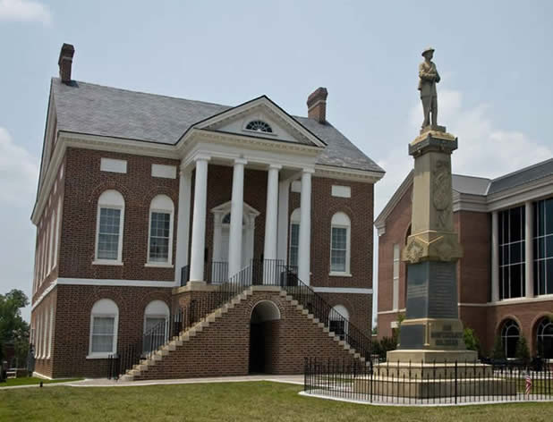
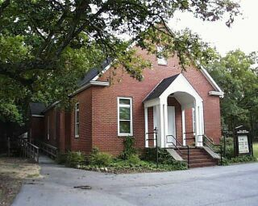
Originally inhabited by the Catawba, Cherokee and Waxhaw Indians, Lancaster's story began in the early 1750s when a vanguard of Scotch-Irish immigrants seeking inexpensive land and religious freedom moved into the area known as the Waxhaws (now northern Lancaster County) and established a settlement. A second colony was soon developed by English (Welsh), German and Scotch-Irish newcomers from Virginia, North Carolina and Pennsylvania in southern Lancaster County.
Lancaster's name can be traced from fifteenth-century England, when the War of the Roses was fought between the House of Lancaster and the House of York, through their first settlement in Lancaster, Pennsylvania, and down to the county that was established in South Carolina in 1785 with the red rose, the insignia of the House of Lancaster, as its emblem.
South Carolina native and Washington Monument architect Robert Mills designed the historic Lancaster County Courthouse in 1828. This hall of justice is a National Historic Landmark that continued to fulfill its court responsibilities until August, 2008, when an arson attempt severely damaged its roof, second and third floors. The 181-year-old building has been restored as closely as possible to its original appearance. Next door is the new Courthouse for Lancaster County.
Robert Mills had been employed earlier to design the Lancaster County Jail in 1825, in use today as government offices. A walking tour of historic downtown Lancaster would also include the Old Presbyterian Church and Cemetery built in 1862; the home of Colonel Elliott White Springs, textile industrialist, which was built in 1825; and the site of Lancaster Academy, the county's oldest continuous public school, founded in 1799.
The entire county abounds with landmarks of historical significance. Much can be learned about Lancaster native and seventh President of the United States Andrew Jackson at the State Park established in his honor. The Waxhaw Presbyterian Church and Cemetery, completed in 1755, was the first church in the area – Andrew Jackson's father is buried there, and a statue of his mother is in the graveyard. Services continue at the church today. In southern Lancaster County, the Mt. Carmel A.M.E. Zion Campground, which was established by the freedmen, has been a meeting site since the 1870s. Kilburnie, which had been the oldest standing residence in the City of Lancaster, has been moved and lovingly restored as an historic bed and breakfast.
Charles Duke, astronaut and moon-walker, grew up in Lancaster, and actress/early Broadway star Nina Mae McKinney was a Lancastrian and so was Dr. J. Marion Sims, known as the “father of modern gynecology.” Another Lancastrian we are proud of is William R. Davie, ambassador to France and founder of the University of North Carolina.
Websites:
www.musclancastermedicalcenter.com
www.lancasterchambersc.org
www.lancastercitysc.com/performingarts.aspx
www.scartshub.com/venues/the-cultural-arts-center

What Previous Students Say About MUSC Lancaster

“I felt that the site, as a whole, is a good learning experience. “

“My overall experience was great!”

“I was very pleased all year with my site.”

“The staff was very friendly to us and make you feel at home in Lancaster. I enjoyed my experience very much and would highly recommend Lancaster to every 3rd year VCOM student.”

