Connect to eduroam with Windows

1. Near the lower-right of your screen, in the notification area, click the network icon.
2. Select eduroam. 3. Click the Connect button.
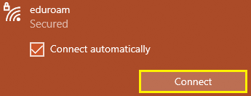
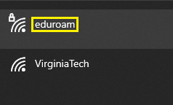
4. In the User name text box, type your VCOM email address in the format example@vcom.edu but replace example with your VCOM Username (PID).
5. In the Password text box, type your network password.
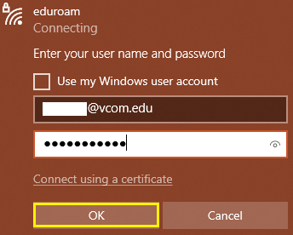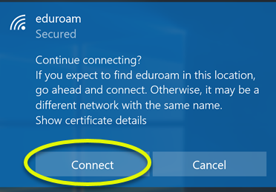
6. Click OK. You will be 7. If asked to accept a certificate, follow connected to the eduroam prompts to accept / install the certificate. network.
If you cannot connect take the following steps:
On windows 10 try forgetting the eduroam network by right clicking on the network icon and selecting Open Network and Internet Settings. Click Wi-fi on the side bar, then click manage known networks. Find and select eduroam and click Forget. Then retry connecting to eduroam.
You can also forget the network on windows 10 by selecting the network icon at the bottom right of your screen. Then right click on eduroam and select “Forget” from the dropdown box.

